OpenWarp - Meshing and Simulation Assembly

Revision History
Author | Revision Number | Date
caoweiquan322 | 1.0 | 09/15/2014

1. Organization of Submission 3
2. Application Setup 3
2.1 Environment 3
3. Deployment 3
3.1 Common steps 3
3.2 Steps for windows 3
3.3 Steps for MAC OS X 4
4. Verification 4
4.1 Mesh generator - Windows 5
4.2 Simulation - Windows 7
4.3 Mesh generator - MAC OS X 9
4.4 Simulation - MAC OS X 10
5. Resource Contact List 11

Organization of Submission
The content of submission follows directory structure provided below:
doc – Contains this deployment guide.
src – Contains the whole tool suite of this assembly.
test_files– Contains files that help verify this submission.

Application Setup

Environment
- Windows 7 64bit
- Mac OS X 10.9 64bit
- Python 2.7.8 X64 https://www.python.org/
- CherryPy 3.5.0 http://www.cherrypy.org/
- Nemoh https://github.com/lawsonro3/Nemoh
- Chrome/Firefox/Safari

Deployment

Common steps
First you need to have Python 2.7.8 installed on your OS.

After that type commands below to ensure that python has been successfully installed and properly configured:
python -V
>>> Python 2.7.8

Now download CherryPy 3.5.0 from http://www.cherrypy.org/ and extract the compressed file. Run following commands to install CherryPy to your python environment:
cd CherryPy-3.5.0
python setup.py install

Steps for windows
On windows, you would need having the Nemoh tool suite and nglib-mesh.exe compiled according to the previous assemblies for Windows provided at forum.

However, I have provided pre-compiled executable files for Windows 7(64 bit). Check them in folder “src\bundled\mesh-generator\bin” and “src\bundled\simulation\bin”. So that you don’t need to compile yourself.

Note that in case you met visual studio dependency issues, please download and install VS2010/VS2012 redistribution package for X64 here:
http://www.microsoft.com/en-us/download/details.aspx?id=14632
http://www.microsoft.com/en-us/download/details.aspx?id=30679#

Please do note that this submission does NOT work well with IE browser. I suggest you install browsers like Chrome/Firefox/Safari and set one of them as the default browser before verify this assembly.

Steps for MAC OS X
On MAC, you would need having the nglib-mesh compiled according to the previous assemblies for MAC provided at forum.
Please refer to the previous assemblies here:
http://apps.topcoder.com/forums/?module=Thread&threadID=829570&start=0

Unluckily, there’s no instructions on compiling Nemoh on MAC OS X. I used a mocked one here. I have prepared the pre-compiled mocked binaries under “/src/bundled/simulation/bin” of this submission. It just print a text line simply.

There’re important two tips for compiling on MAC OS X:
- You may need to configure “/src/openwarp/settings.py” to change the listening port to some value other than 80, say 8000. Otherwise you would meet permission issues.
- You should first try to run “nglib-mesh” via terminal to ensure that the configuration and library dependencies are all right. In case you met .dylib dependency or loading issues, a short hack python script named “/src/bundled/mesh-generator/lib/update_dylib.py” might help.

Verification
Open one terminal, go to folder “/src” of this submission. Run following command to start the application:
python main.py

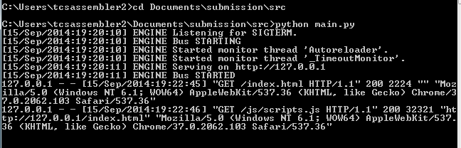

After seconds, the default browser would open page http://127.0.0.1:80/index.html .

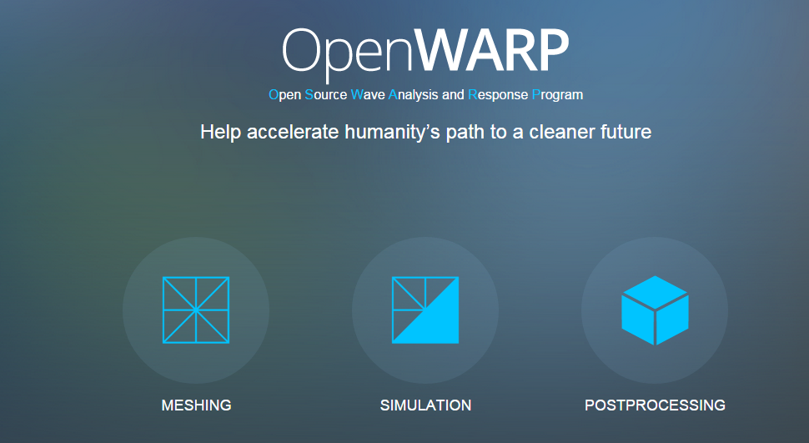

Mesh generator - Windows
Go to “MESHING” page. Please refer to the configuration parameters in “/test_files/mesh/config.txt” of this submission as below to fill in the forms:

infile: FlapSingle.stl
# outfile without extension
outfile: flap-meshed

maxh: 50
minh: 0.35
fineness: 0.4
grading: 0.1

# set one to use tolerace, otherwise 0
usetolerance: 0
# volume tolerance in percent
tolerance: 1

See the screen shot below:

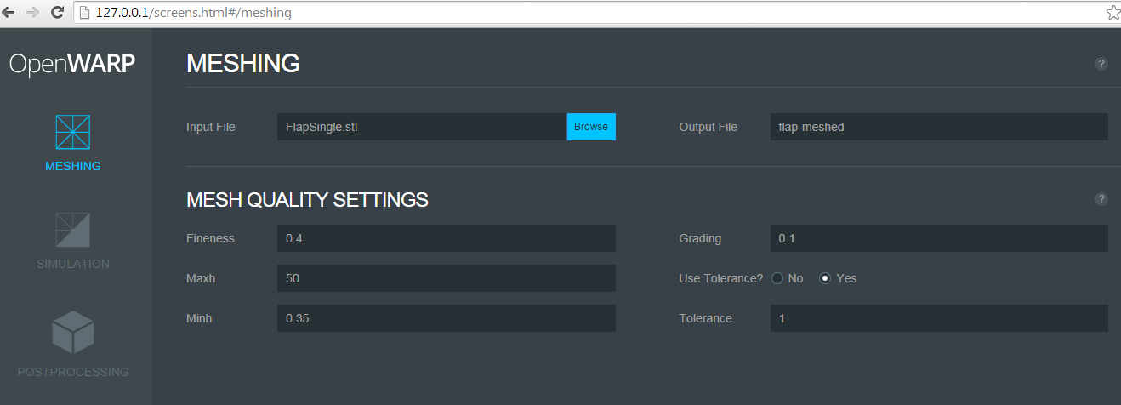

Click “Browse” button to upload the correct 3d files to server. Choose “/test_files/mesh/FlapSingle.stl” for example.
Click the “EXECUTE” button to submit the parameters to server side and generate mesh files. A “Loading ...” dialog pops up to prevent you from editing and clicking anything of this page.

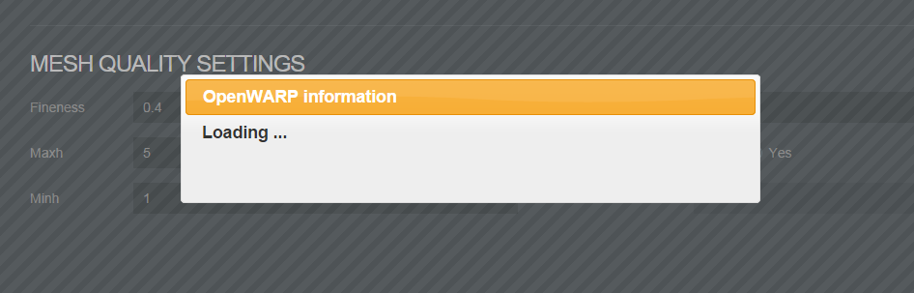

Notice the python log information, which shows that the nglib-mesh process has started and not finished yet.

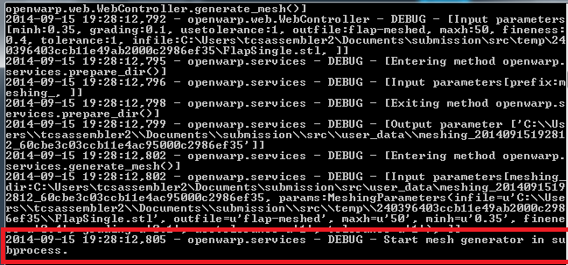

After the mesh generator finished, see the client side got the running log. The message was displayed in a popup dialog.

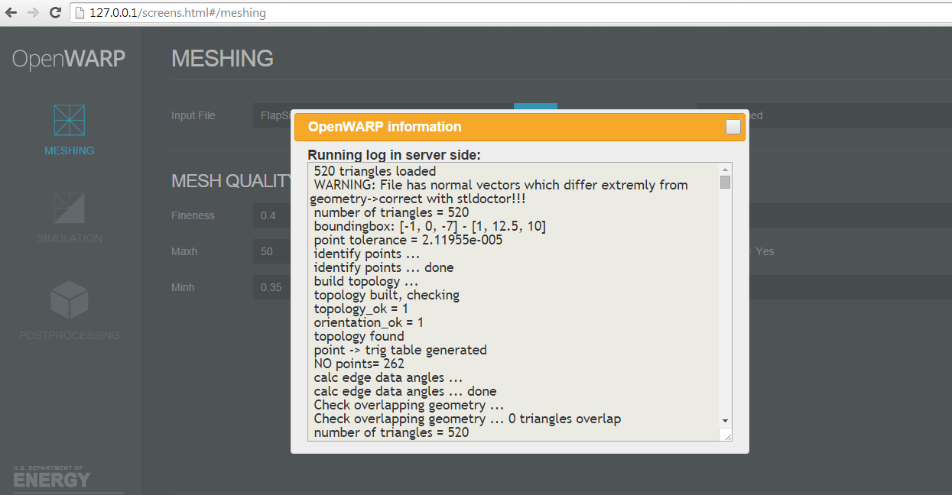

You may also check the generated mesh files in some path like “src/user_data/meshing_20140915192812_60cbe3c03ccb11e4ac95000c2986ef35”. The really path may depends since a UUID was used to avoid conflicts.

You may try input some invalid value to see that the application is able to recognize and report the error. For the example below, I input a value “6” for “Fineness” while it should be no larger than 1.

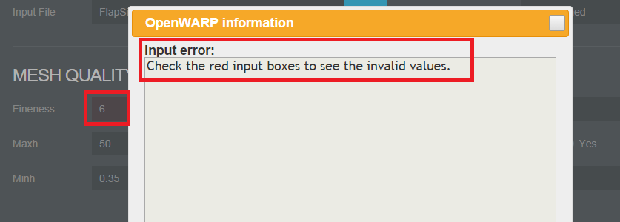

Simulation - Windows
Go to “SIMULATION” page. Please reference the configuration parameters in “/test_files/simulation/flap-meshed-quad/Nemoh.cal” and “/test_files/simulation/flap-meshed-quad/input.txt” to fill in the forms:

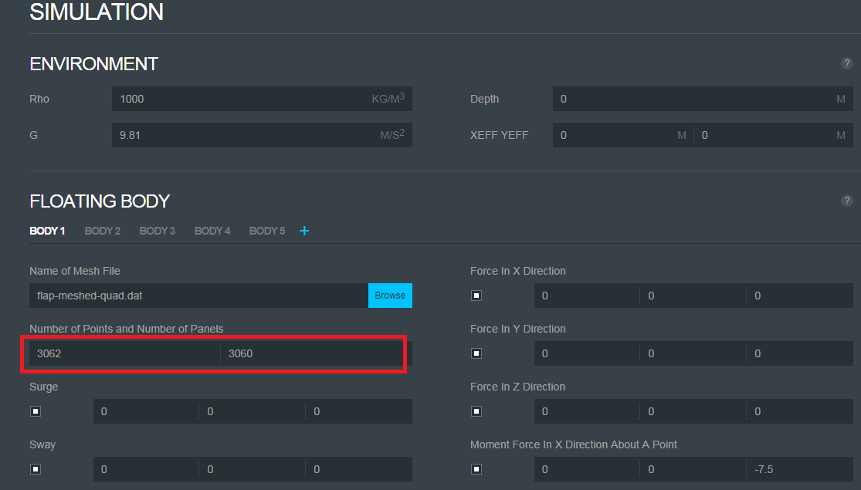

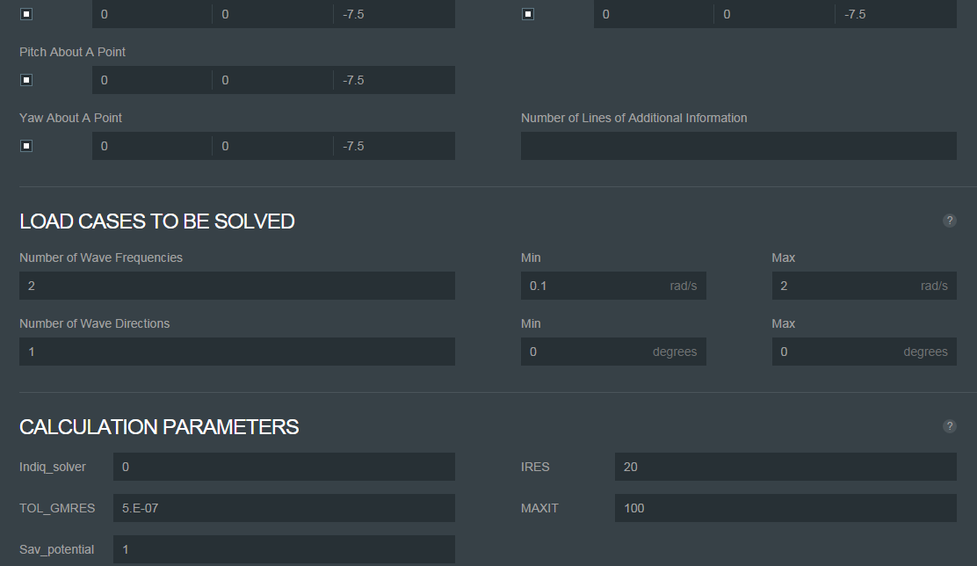

Click “Browse” button to choose the mesh file you have just created using “MESHING” tool. For my machine, it’s located in “src/user_data/meshing_20140915192812_60cbe3c03ccb11e4ac95000c2986ef35/flap-meshed-quad.dat”.

Note that the value 3062 (points) and 3060 (panels) are calculated and returned from server automatically after the mesh file were uploaded.. You do NOT need to input them manually.

Then click the “EXECUTE” button to start simulation. You may check the python output to see that the “solver” process has started and not completed yet.

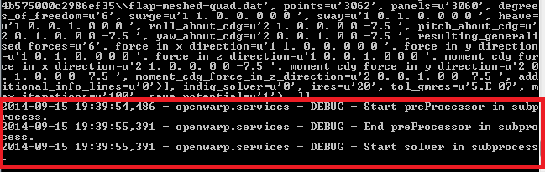

After solver finished working, you may check the running log information displayed within browser:

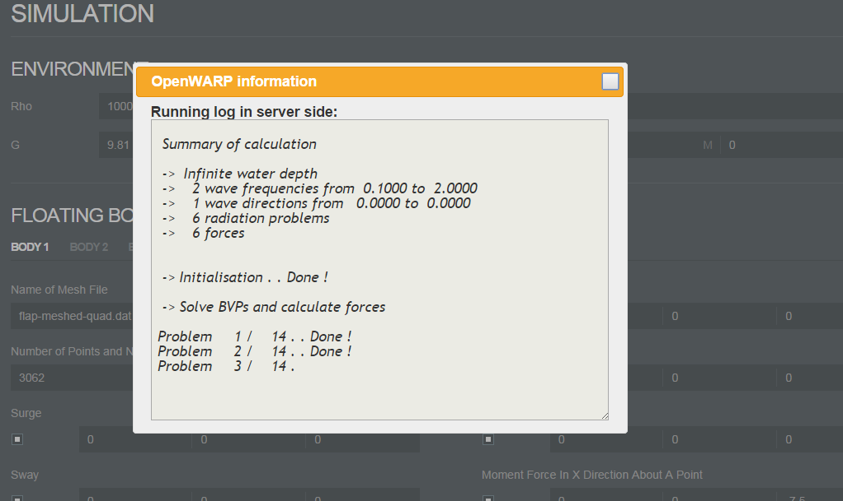

Note that for verification purpose, you may just terminate the “solver” process manually since it cost too much time before finish. This won’t affect the whole work flow of this assembly.

You may also try some invalid input values to see that the error would be detected by browser client side.

Mesh generator - MAC OS X
The operations on MAC OS X are all the same with that of Windows.
See the successful screenshots below:

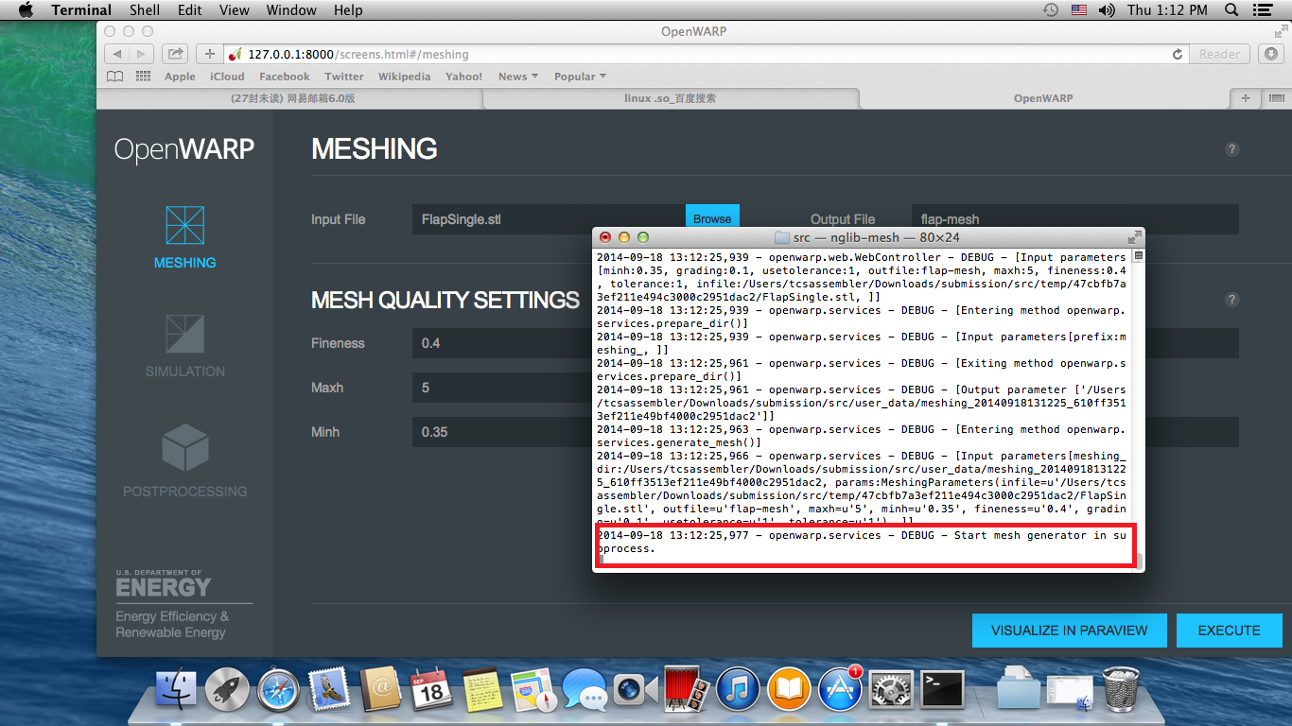

The nglib-mesh was correctly invoked.

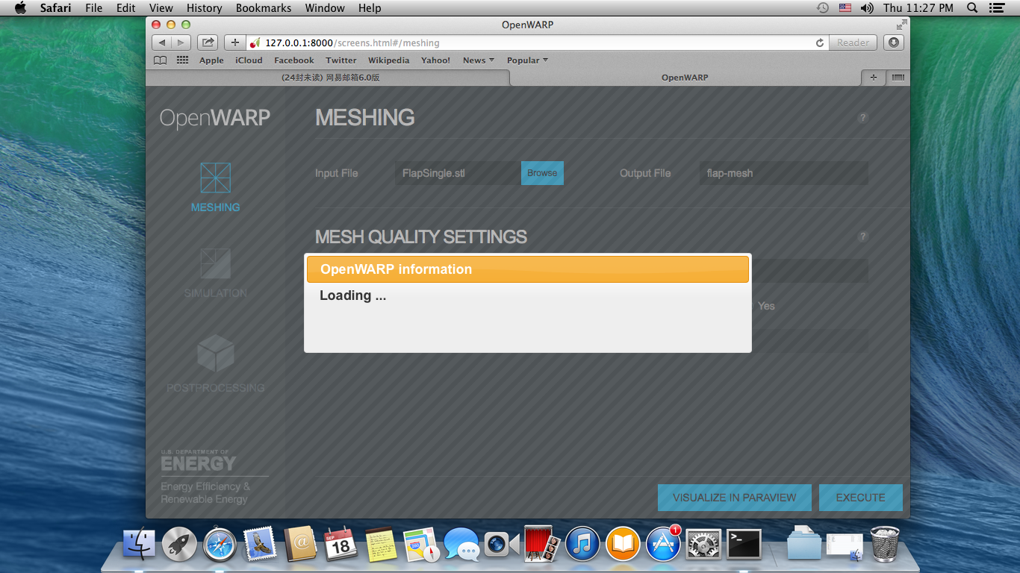

“Loading ...” dialog prevents user from clicking buttons and editing fields.

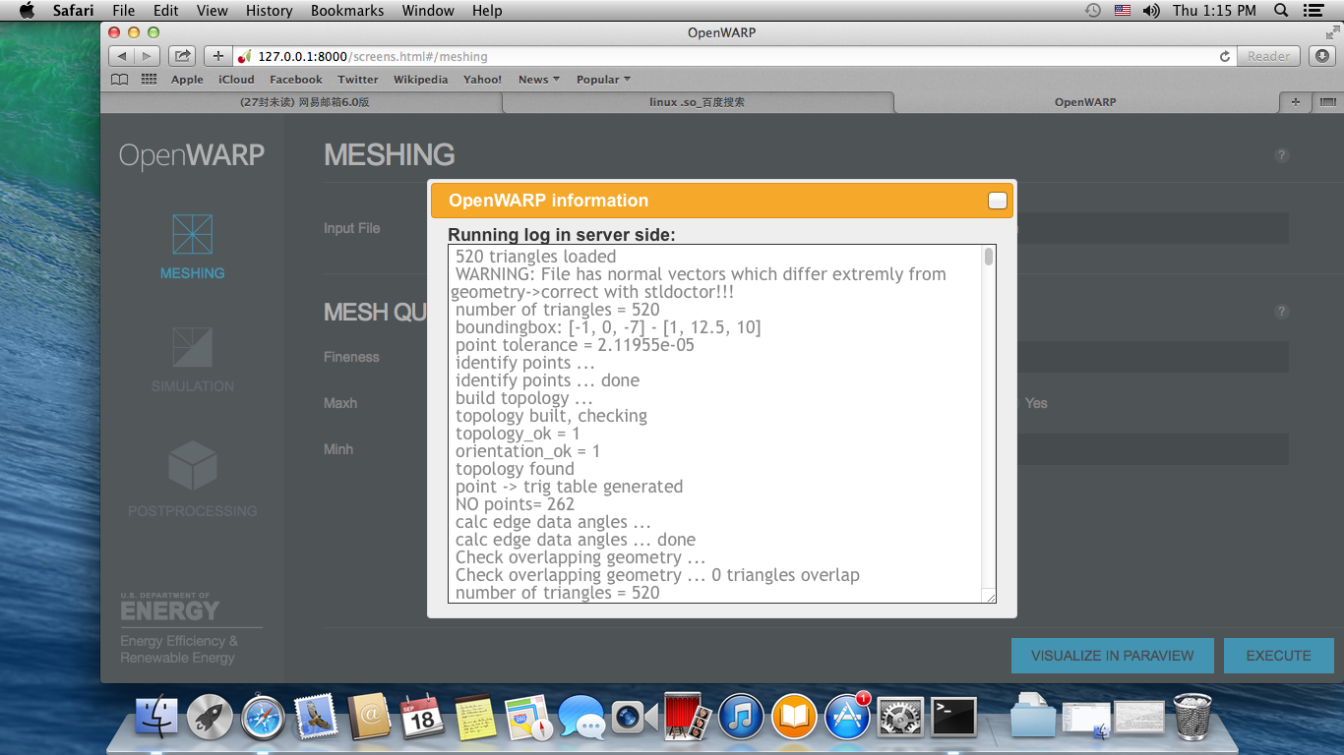

The correct result was logged and returned to client.

Simulation - MAC OS X
The operation on MAC OS X is all the same with that of Windows.
See the successful screen shots below:

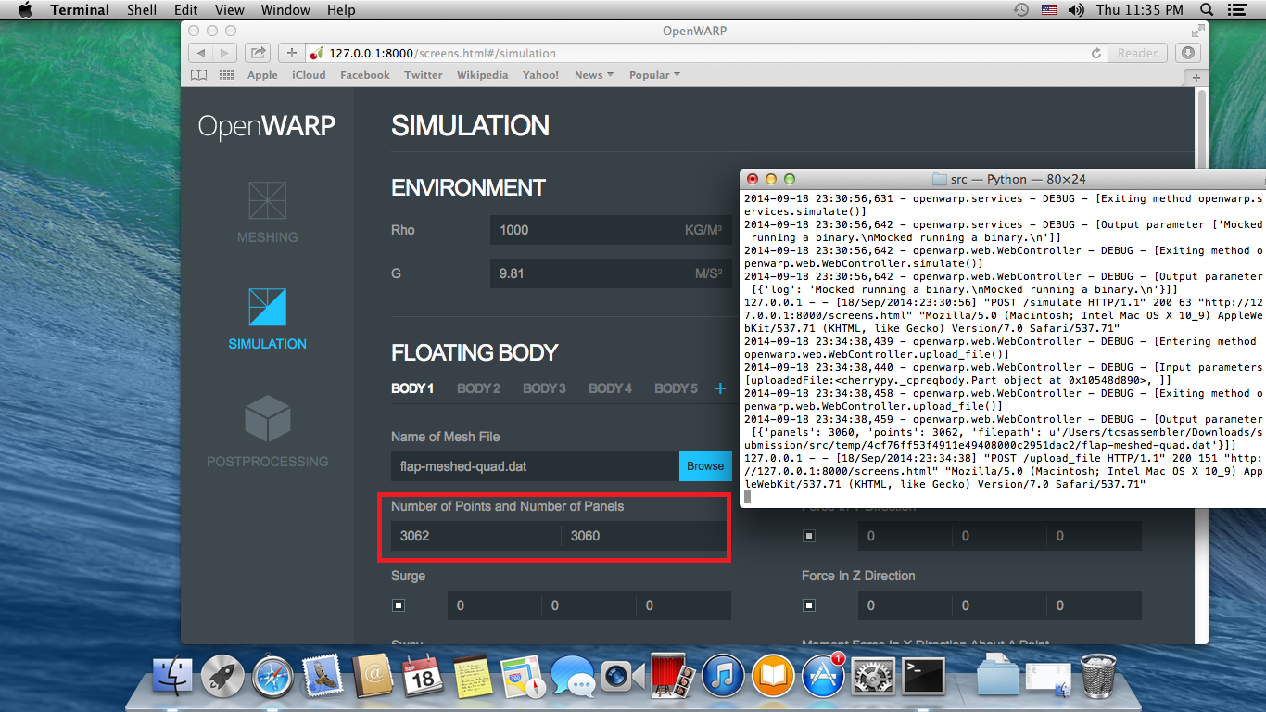

The mesh points and panels were determined by server and posted back to client.

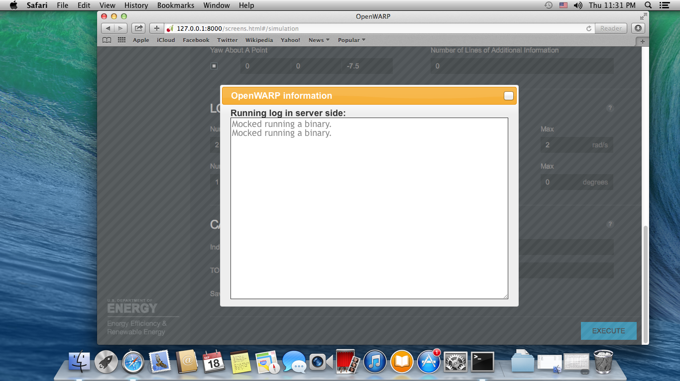

Mocked Nemoh executables were invoked.

Resource Contact List

Name | Resource Email
caoweiquan322 | caoweiquan322@126.com

